
Weekend Class
Business Chinese (intermediate, advanced)
International College of Chinese Studies,
Shanghai Normal University, 2019

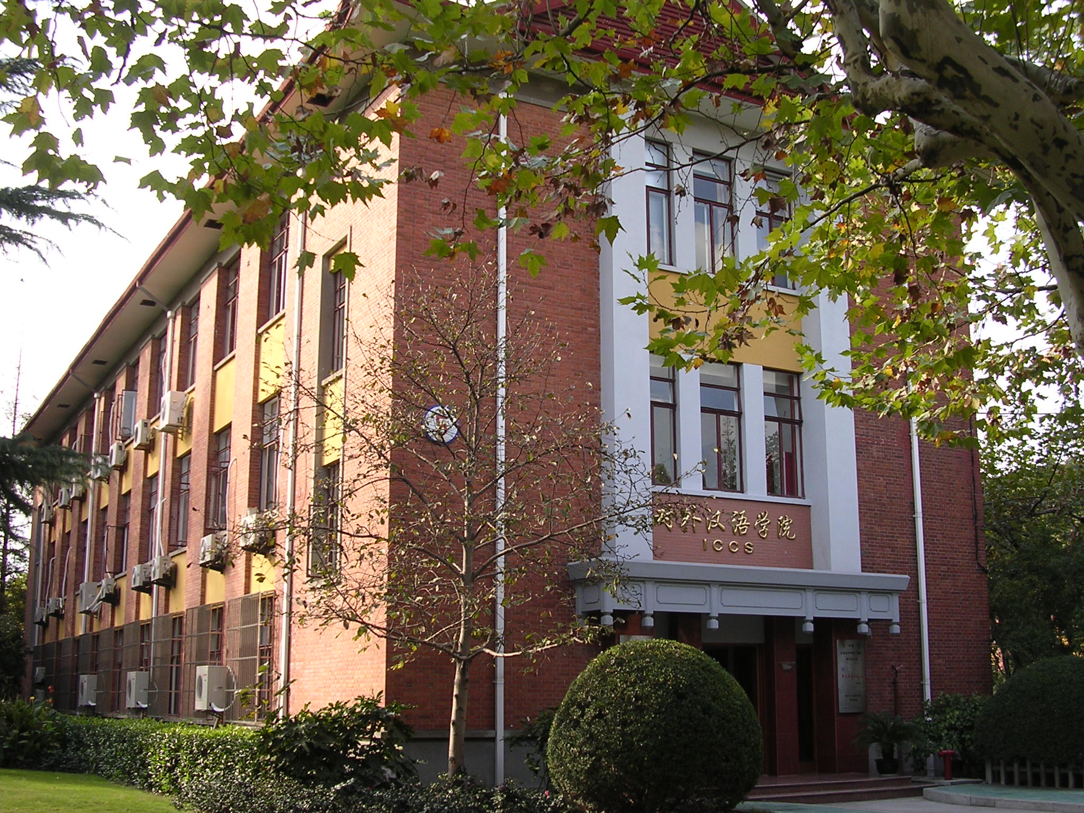
★Teaching Aims: After training, students should be familiar with the business professional terms, improve their business communication skills, be able to use Chinese to greet and accept customers, talk about business, write business letters, make plans and sign contracts.
- Class Time：09:00～12:00 a.m.(every Saturday)
Sept 21th.2019 – Jan 11th 2020(15 weeks, university will break up on Jan.4th for holidays)
- Application Deadline：Sept 20th 2019 (Friday)
- Class Venue：1st Floor, International College of Chinese Studies, Shanghai Normal University, No.100 Guilin Road.
- Application fee：RMB400（FREE OF CHARGE FOR ICCS REGISTERED STUDENTS）
- Tuition fee: RMB3000

1st Floor, International College of Chinese Studies, Shanghai Normal University, No.100 Guilin Road.
Levels | Courses | Chinese Requirements
Business Chinese  (intermediate) | Business Audiolingual-visual Course,  Business Case Analysis Course  (Intensive Reading and Writing) | Students in Elementary 3, Intermediate 1, Intermediate Business Chinese are recommended to study in this level.
Business Chinese  (advanced) | Business Audiolingual-visual Course,  Business Case Analysis Course  (Intensive Reading and Writing) | Students in Intermediate 2, Advanced 1, Advanced Business Chinese, Third-year undergraduates, Fourth-year undergraduates
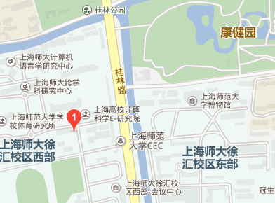 | Application Time:  08:00～11:15a.m.，01:00～05:00p.m., Monday to Friday  Application Venue：  Room 206, International College of Chinese Studies, Shanghai Normal University, No.100 Guilin Road.  Application Hotline：  64322824 （Korean, Japanese） 64322452 （English）  Fax：64321654 Website：http://iccs.shnu.edu.cn  Transportation: Metro Line 12 (Guilin Park), Line9 (Guilin Road); Bus No804, 830,909,732,224,946,etc.

