21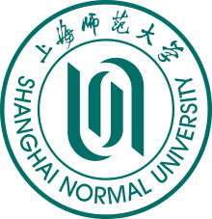 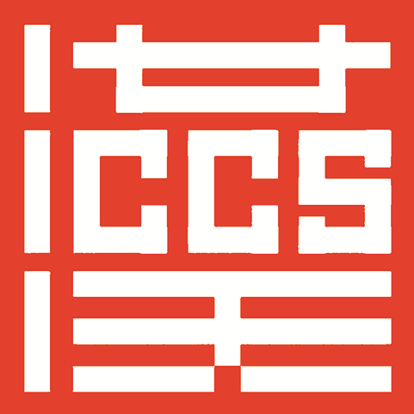
An Enrollment Guideline to Online Short-term Chinese Language Learning Programs (evening class), International College of Chinese Studies, Shanghai Normal University (Fall Semester)

In order to meet the needs of foreigners to learn Chinese in the evening, ICCS will set up an online short-term Chinese learning programs (evening class) in the fall semester, 2020. Some detailed information is listed as follows:
Type of Class | Enrollment Target | Teaching Objective
Tutorial Class for HSK-5 | For those students who have the intermediate level | For those students who want to take HSK-5 examination
Tutorial Class for HSK-6 | For those students have the advanced level | For those students who want to take HSK-6 examination
Business Chinese (Intermediated Class) | For those students who have the intermediate level | To help students master the basic business terms, improve Business Chinese communicative ability so that students can be appropriate in receiving customers, negotiating business, writing letters, making plans and signing contracts, etc.
Business Chinese (Advanced Class) | For those students have the advanced level | To help students be familiar with business terms, improve business Chinese communicative ability so that students can accurately and fluently receive customers, negotiate business, write letters, make plans and sign contracts.
- Time for class：the first period (Sept.21～Nov.13) / the second period（Nov.23～Jan.15）
- Time for studying：8 weeks per period，every Monday, Tuesday and Thursday 18:30～20:00（Beijing Time）
- Ways to attend class：online teaching
- Tuition fee：RMB 3000/period，E-text（free of charge）
- Date of application：Registration begins today, with the first period ending on Sept.17 and the second period ending on Nov.19.
- Application materials：application form, one photo (passport-size), passport-copy.
- Attention: Students will be granted the certificate if pass the exam.
- How to apply?
Tel.: +86-21-6432-2824+86-21-6432-2452
Website: http://iccs.shnu.edu.cn/cn
- mail: iccs@shnu.edu.cn （English）
yeewen@shnu.edu.cn (Korean)
ysm@shnu.edu.cn (Japanese)

