
Weekend Class
Business Chinese (intermediate, advanced)
International College of Chinese Studies,
Shanghai Normal University, Feb. 2020

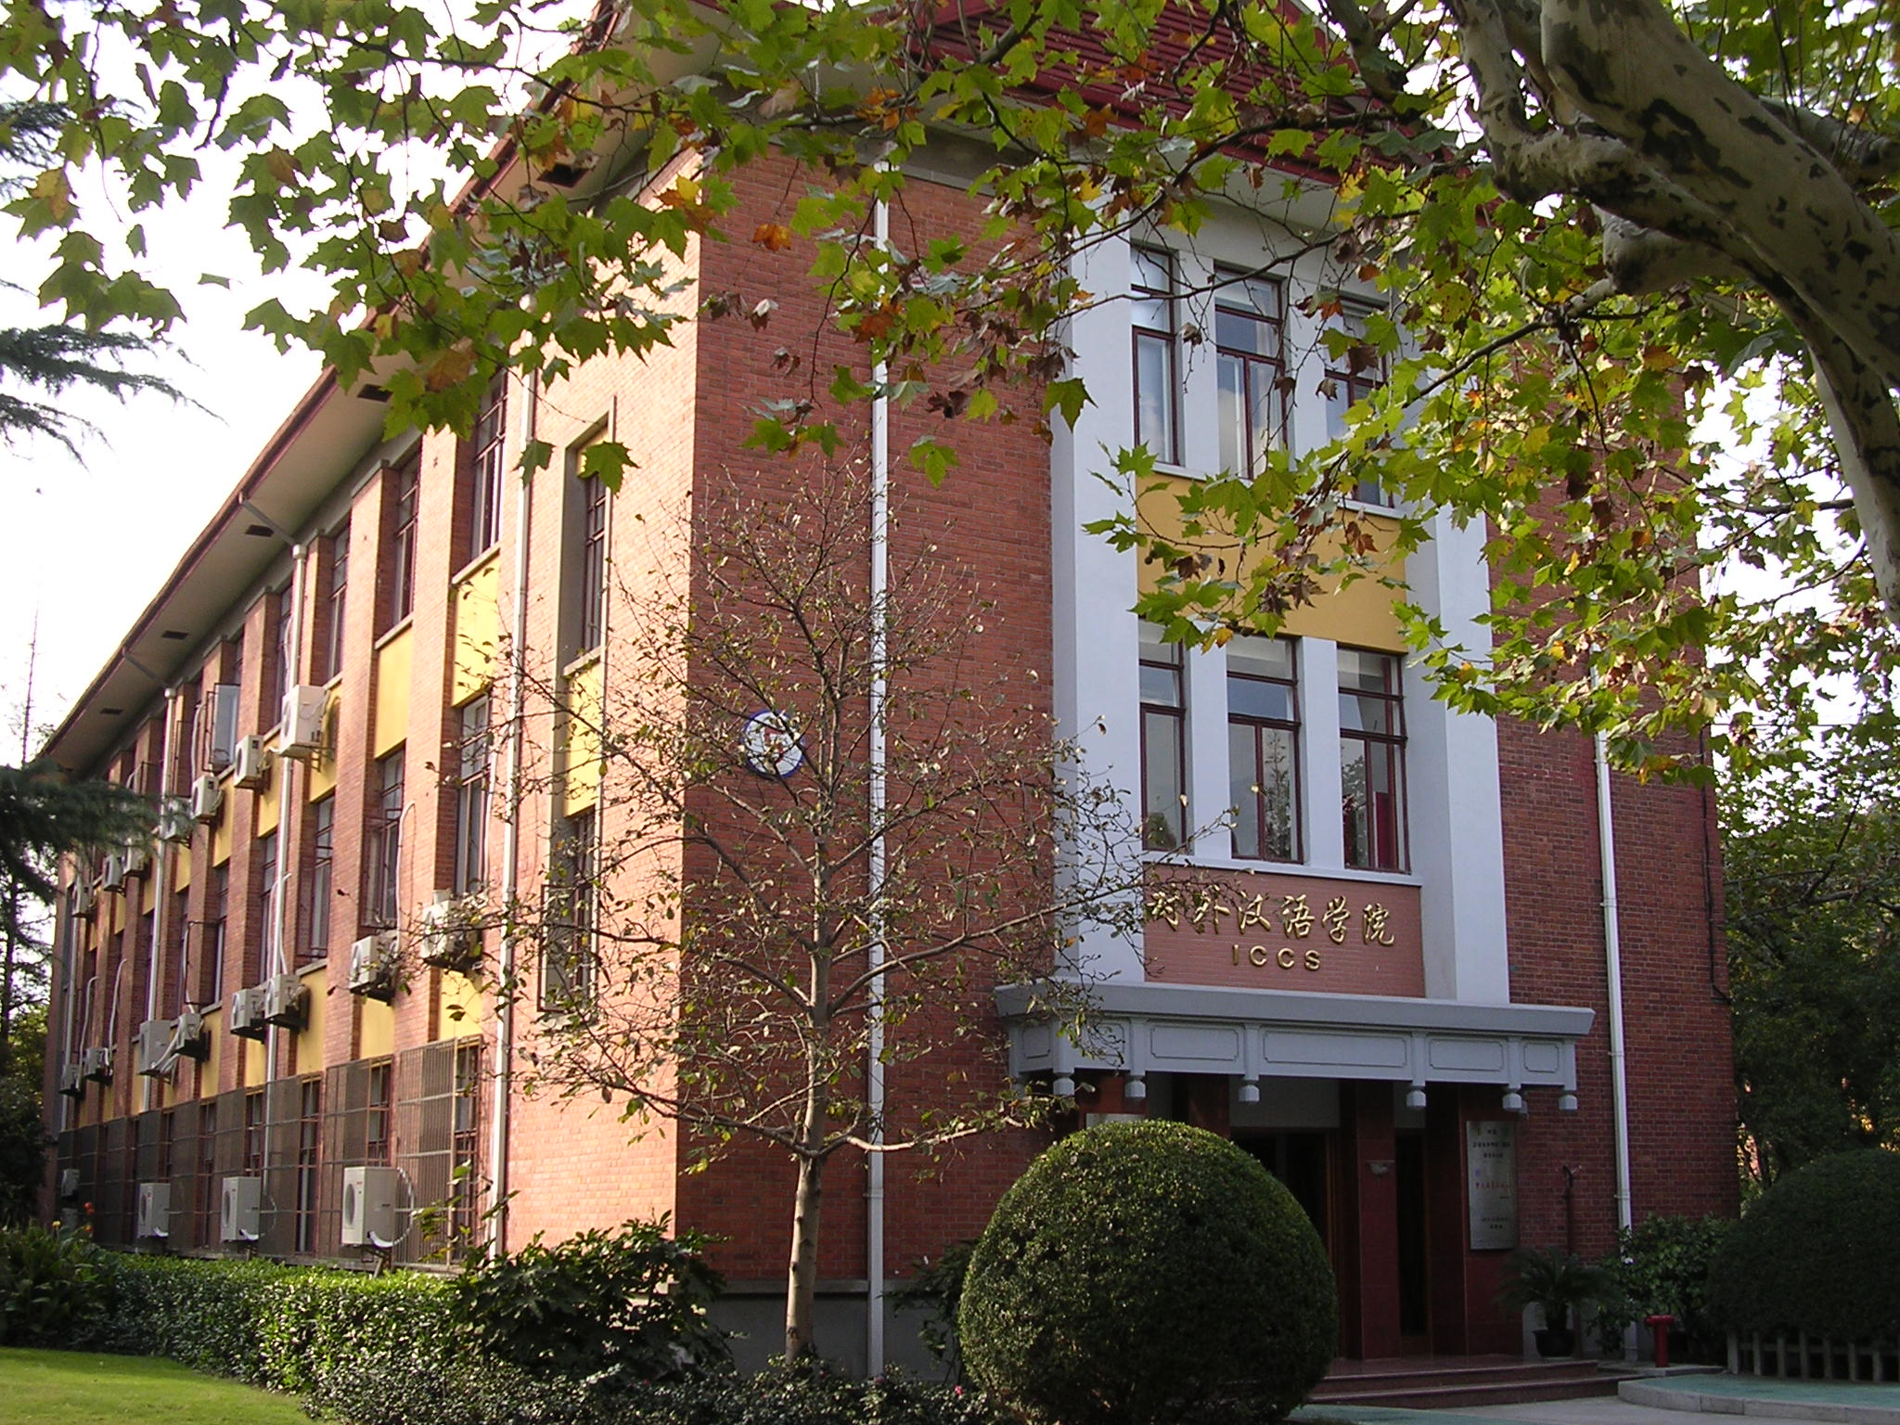
★Teaching Aims: After training, students should be familiar with the business professional terms, improve their business communication skills, be able to use Chinese to greet and accept customers, talk about business, write business letters, make plans and sign contracts.
- Class Time：09:00～12:00a.m.(every Saturday)
Feb. 29th2020 – June 20th 2020(15 weeks, university will break up on Apr.4th and May.2nd for holidays)
- Application Deadline：Feb. 28th, 2020 (Friday)
- Class Venue：1st Floor, International College of Chinese Studies, Shanghai Normal University, No.100 Guilin Road.
- Application fee：RMB400（FREE OF CHARGE FOR ICCS REGISTERED STUDENTS）
- Tuition fee: RMB3000

Levels | Courses | Chinese Requirements
Business Chinese  (intermediate) | Business Audiolingual-visual Course,  Business Case Analysis Course  (Intensive Reading and Writing) | Students in Elementary 3, Intermediate 1, Intermediate Business Chinese are recommended to study in this level.
Business Chinese  (advanced) | Business Audiolingual-visual Course,  Business Case Analysis Course  (Intensive Reading and Writing) | Students in Intermediate 2, Advanced 1, Advanced Business Chinese, Third-year undergraduates, Fourth-year undergraduates
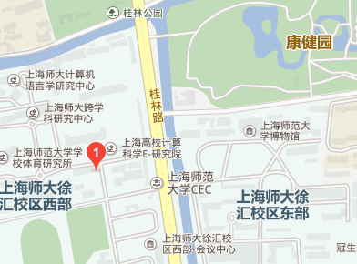 | Application Time:  08:00～11:15a.m.，01:00～05:00p.m., Monday to Friday  Application Venue：  Room 206, International College of Chinese Studies, Shanghai Normal University, No.100 Guilin Road.  Application Hotline：  64322824 （Korean, Japanese） 64322452 （English）  Fax：64321654 Website：http://iccs.shnu.edu.cn  Transportation: Metro Line 12 (Guilin Park), Line9 (Guilin Road); Bus No804, 830,909,732,224,946,etc.

